English 11/12 Honors: Tolkien Name:
Mr. Fisher

Vietnam, ruled by communists for 40 years, is now the No. 1 fan of capitalism on the planet
By Matt Phillips, Quarts Magazine, 4/29/15

It’s been 40 years since the harrowing rooftop helicopter evacuations of Saigon, then the capital of South Vietnam, which marked the end of America’s military involvement in a conflict that left roughly 58,000 Americans dead, sharply divided the country, and damaged America’s self-confidence until the 1990s.

The Vietnamese suffered far more casualties, with estimates ranging from 1 million to 3 million. This paper suggests that the best estimate is that roughly 1 million North Vietnamese combatants were killed, along with 250,000 South Vietnamese soldiers. The number of civilians killed in both the north and the south remains unknown.

On April 30, 1975, the North Vietnamese tanks rolled into the Presidential Palace—today Reunification Palace—and the South Vietnamese government surrendered that day, bringing two decades of conflict to a close.

Understandably it took a long time for relations between Vietnam and the US to get anywhere close to warm. The US didn’t take steps to normalize relations until 1991. President Bill Clinton ended the trade embargo in 1994 and fully normalized relations in 1995.

Much like China, Vietnam remains an authoritarian country today. And it’s communist, too, but in name only. Things have changed a lot over the last 40 years. According to a recent Pew Research survey, Vietnam today has the single most positive views on capitalism of any country, with an enthusiasm that is even more widespread than in Germany, India, or the United States.
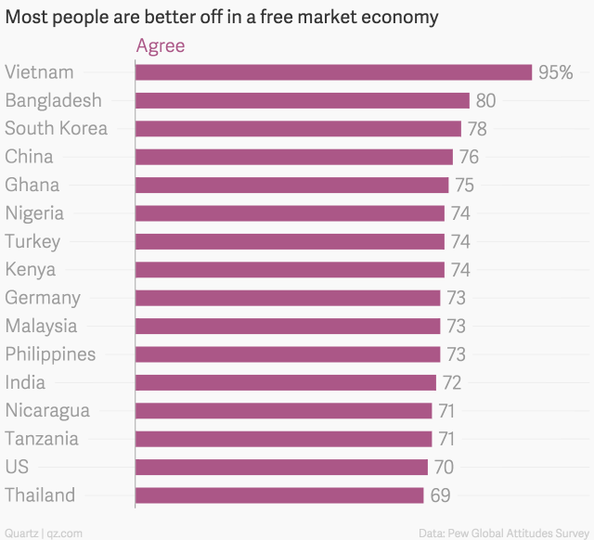

Based on the article on the other side of this paper and the New York Times article, “Capitalist Soul Rises as Ho Chi Minh City Sheds Its Past,” please answer the following questions. You can work in groups of up to three students, or work alone. It’s up to you.

- What are possible reasons, based on these two articles and what you read in Catfish and Mandala, that the Vietnamese are now embracing capitalism?

- How do the young Vietnamese men and women see their country’s past? Do you think this is a good perspective for them to have? Why or why not?

- How is the picture of Vietnam painted by these two articles similar to the one described by Andrew Pham in Catfish and Mandala?

- How is the picture of Vietnam painted by these two articles different from the one described by Andrew Pham in Catfish and Mandala?

