Researching Injustice

We live in a world that includes a seemingly endless number of examples of injustice, from social injustices to economic injustices to political injustices.

Prompt: Choose an injustice in the world today. In your five to seven page research paper, you will explain what is happening, why it is an injustice, and give a possible, realistic solution for the injustice.

Requirements:
- Proposal—Due 3/28
- Annotated bibliography—Due 4/6
- Outline—Due 4/13
- Rough draft—Due 4/25
- Final copy—Due 5/2

Proposal:
Your proposal should be a paragraph long and include:
- Which injustice you want to research
- Why it should be researched and discussed
- Citations of two reliable sources that you have found that discuss your topic (these can just be included at the bottom of your proposal- you do not need to incorporate quotes from them into your proposal)
This will not be graded, but is a necessity to earn a grade on your research paper.

Annotated Bibliography:
Your annotated bibliography should include citations and annotations for 5 reliable sources that you intend to use on your paper. Each annotation should summarize, assess, and reflect on the source you chose. More information and an example from Purdue OWL can be found below.

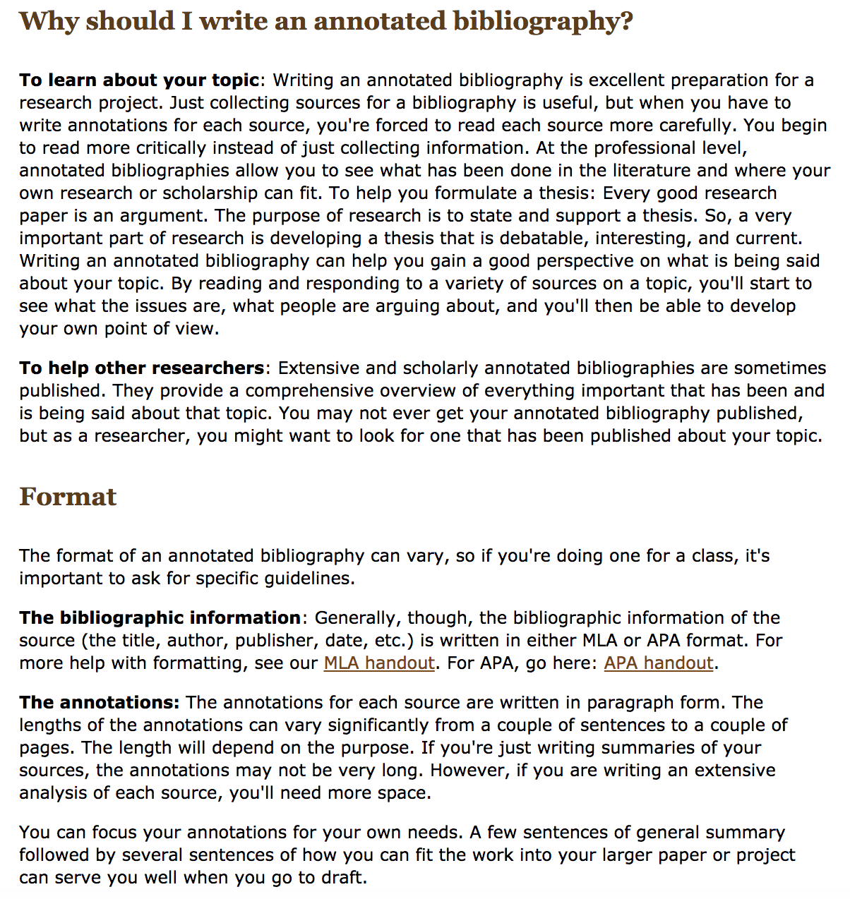
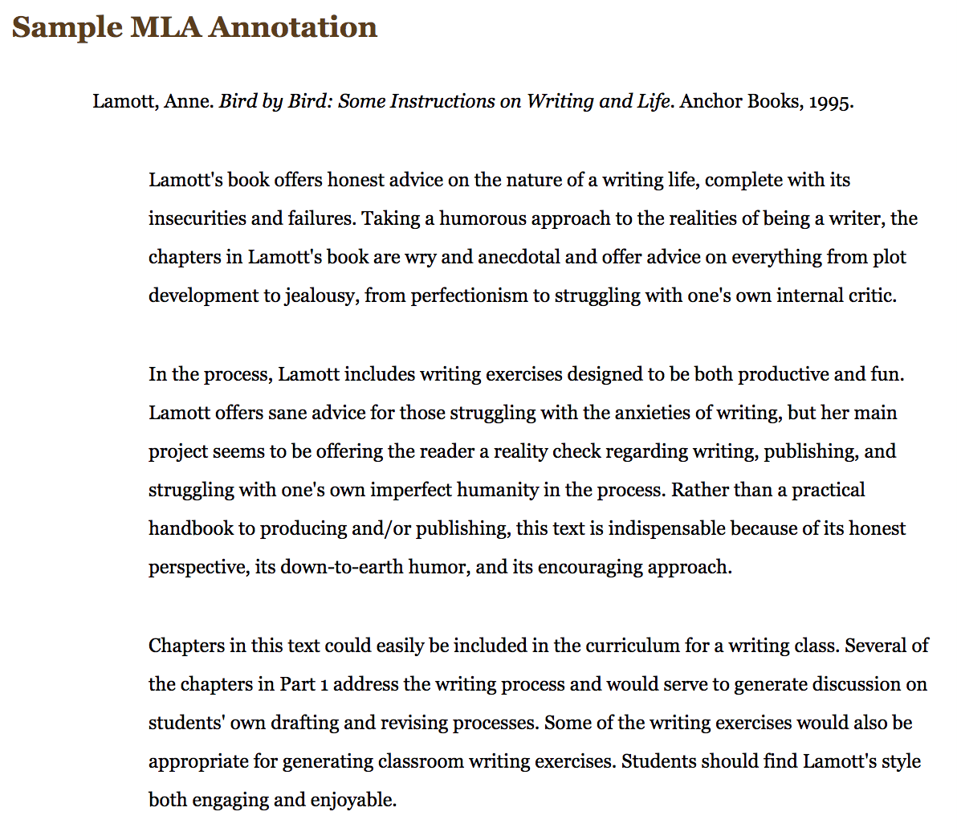

Outline:
See the next page for the first page of a sample outline. Type your outline using the correct format. Note that the thesis statement is included on the outline.

Daria Astorino
0.5”
1”
Double space entire outline
Astorino 1
Mr. Dougherty
English 10 H
19 May 2003
Teen Smoking
Thesis Statement: Tobacco companies, aiming to keep their profits high, target teens in their advertisements and, by doing so, encourage them to become lifelong smokers.
1”
1”
- Tobacco and Smoking
  - Brief introduction of tobacco to the United States
  - Widespread use
    - Relaxation
    - Appeal
  - Nicotine
    - Poisonous alkaloid
    - Effects on brain and nervous system
    - Addiction
- Tobacco Advertising
  - Trends in tobacco use
  - Consumption of cigarettes
    - Recent decline in adult consumption
    - Recent rise in teen consumption
  - American teens
    - Recruiting of new clients—teens
1”
Rough Draft:
The less rough, the better. The more organized and complete your rough draft is, the more time you will have to work on improving format, mechanics, grammar, and transitions of the essay. You may discover that you need to add more content to your draft at this point. For this reason, it is important to save all sources you have found during the project.
- In order to get credit for your rough drafts, you must SHOW ME A COMPLETED COPY, which includes your works cited page, in the beginning of the period that it is due. You cannot get full credit otherwise. In other words, a few scribbled sentences will not be enough.
- There will be no extensions for rough drafts. If you are not here on the day the rough draft is due, it must be due to an excused absence in order to get credit. Even then, it must be handed in within 48 hours of your absence to earn credit.

Final Copy:
Your paper must include:
- What your injustice is
- The circumstances surrounding your injustice (what is happening?)
- Why it is an injustice
- A possible, realistic solution for the injustice
- At least 5 reliable sources
- At least 5 direct quotations (Unquoted citations, though necessary, do not count as quotations.)
- Properly formatted and accurate in-text citations according to MLA formatting
- A properly formatted and accurate works cited according to MLA formatting—A PAPER SUBMITTED WITHOUT A WORKS CITED WILL RECEIVE, AT BEST, AN AUTOMATIC 110/200
- A thesis, which will be the last sentence of the introductory paragraph

Format: typed, Times New Roman, 12 point font, double spaced, one inch margins, MLA formatting, beware of tears

Length: 5-7 pages

See the next page for a sample of the first page of a properly formatted paper.

Daria Astorino
0.5”
1”
Double space entire paper
Astorino 1
Mr. Dougherty
English 10 H
19 February 2018
Indent 0.5” from the margin
Teen Smoking: Are Tobacco Companies to Blame?
Evidence continues to mount regarding smoking as a health hazard. Every day, while adults are trying to quit, more and more teenagers begin the habit. This trend exists because tobacco companies, aiming to keep their profits high, target teens in their advertisements and, by doing so, encourage them to become lifelong smokers.
Smoking can be traced back to the days before Columbus. When Columbus and his fellow explorers were colonizing America, the Native Americans introduced them to tobacco. Tobacco was commonplace in the “New World” in 1492, since smoking was looked upon as a peace gesture, a means of relaxation, and an offer of friendship (Alters). Cigarette use, the most widely used form of tobacco, has persisted throughout the United States’ history. According to the National Center for Chronic Disease Prevention and Health Promotion’s 2012 report, in 1964
1”
1”
50% of the U.S. adult male population smoked, and smoking was becoming increasingly prevalent among women and youth. Smoking was also acceptable in nearly all locations, such as worksites, movie theaters, hospitals, and airplanes. Cigarettes were advertised in many different kinds of media and their use was tied to glamour, wealth, sex appeal, popularity, power, and good health. (Preventing Tobacco Use Among Youth and Young Adults)
Indent 1” from the margin
Smoking became a part of the culture that adults and teens associated with popularity, status, and wealth. These associations motivated individuals to begin smoking in order to emulate those who
1”
Rubric for the Final Paper:

Fills all Requirements of the Prompt
1 | 2 | 3 | 4 | 5 | 6 | 7 | 8 | 9 | 10

Detail and Information
1 | 2 | 3 | 4 | 5 | 6 | 7 | 8 | 9 | 10 | 11 | 12 | 13 | 14 | 15

Analysis
1 | 2 | 3 | 4 | 5 | 6 | 7 | 8 | 9 | 10 | 11 | 12 | 13 | 14 | 15

Quality of Sources
1 | 2 | 3 | 4 | 5 | 6 | 7 | 8 | 9 | 10

Incorporation of Sources (direct quotes and paraphrasing)
1 | 2 | 3 | 4 | 5 | 6 | 7 | 8 | 9 | 10

Introduction, Thesis, and Conclusion
1 | 2 | 3 | 4 | 5 | 6 | 7 | 8 | 9 | 10

Organization and Structure
1 | 2 | 3 | 4 | 5 | 6 | 7 | 8 | 9 | 10 | 11 | 12 | 13 | 14 | 15

Grammar, Mechanics, Style, Diction, and Transitions
1 | 2 | 3 | 4 | 5 | 6 | 7 | 8 | 9 | 10
MLA Formatting (citations, paper formatting, etc.)
1 | 2 | 3 | 4 | 5

Grade- _____ x2= _______ / 200

Plagiarism:
Plagiarism is using another person’s thoughts, ideas, words, or work and claiming it as your own. Any person caught plagiarizing on this assignment will earn a zero; further disciplinary action may also be taken. In order to avoid plagiarism, you should use parenthetical documentation to cite any ideas that are not common knowledge and that you received from an outside source.

Plagiarism includes, but is not limited to
- Using someone else’s exact words without citing the source
- Paraphrasing someone else’s exact words without citing the source
- Attributing a citation to the wrong source
- Soliciting another person to write your paper or a piece of your paper
- Using a paper or section of a paper written by someone else
- Reusing a paper that you had written for a different class
- Using the same notes as another student
- Photocopying another student's paper, whiting out his or her name, and replacing it with your own.

Remember, one of the goals of research is to gather and analyze for yourself the ideas of the best scholars on your topic. Citing other scholars gives your paper credibility and is the sign of a mature writer. If you are concerned about mistakenly committing plagiarism, feel free to check with me.

Citations:
In-text Citation Basic Format
(Last name page #)

Ex.) As Atticus Finch notes, “You never really understand a person until you consider things from his point of view . . . until you climb into his skin and walk around in it” (Lee 39).

If there is no page number, just write the author’s last name.

If there is no listed author, first check to make sure that your source is reliable. If it is, write the title of the work in place of the author’s name.

Works Cited General Format for Any Citation
Author. Title. Title of container (self contained if book), Other contributors (translators or editors), Version (edition), Number (vol. and/or no.), Publisher, Publication Date, Location (pages, paragraphs URL or DOI). 2nd container’s title, Other contributors, Version, Number, Publisher, Publication date, Location, Date of Access (if applicable).

Sample Book Citation
Lee, Harper. To Kill a Mockingbird. Grand Central Publishing, 1982.

Sample Database Article Citation
Corfield, Cosmo. “Why Does Prospero Abjure His ‘Rough Magic’?” Shakespeare Quarterly, vol. 36, no. 1, 1985, pp. 31–48. JSTOR, www.jstor.org/stable/2870079. Accessed 28 Nov. 2017.

Sample Work in an Anthology
Shakespeare, William. The Tempest. The Riverside Shakespeare, edited by G. Blakemore Evans, 2nd ed., Houghton Mifflin Company, 1997, 1661-1686.

Sample Online Newspaper Article
Roose, Kevin. “Google Pledges $300 Million to Clean Up False News.” The New York Times, 20 Mar. 2018, https://www.nytimes.com/2018/03/20/business/media/google-false-news.html. Accessed 20 Mar. 2018.

To find more information about how to use citations correctly and to view examples of specific types of citations, visit Purdue OWL’s MLA page.
https://owl.english.purdue.edu/owl/resource/747/01/

Punctuation of Direct Quotes and Citations with Parenthetical Documentation
- Quotation ending in a comma or a period
- Drop the comma or period, close quotes, open parentheses, citation, close parentheses, end with period

“Bob Dylan hugged Mr. Fisher, and called him his biggest fan” (Adams 34).

- Quotation ending in a question mark or exclamation point
- Keep the question mark or exclamation point, close quotes, open parentheses, citation, close parentheses, end with period

“Dylan then invited Mr. Fisher to go on tour with him!” (Johnson 26).

- Quotation which includes dialogue
- Begin the quotation as usual, begin dialogue with “half-quotation marks” or apostrophes, close entire quotation with regular punctuation

“Mr. Fisher responded, ‘Oh, Bob, I couldn’t take that much time away from my students.’ Instead, Mr. Fisher asked Dylan to dedicate his next album to him” (Adams 78).

- A citation or quotation does not end the sentence
- Punctuate as usual but save citation for the end of the sentence

Dylan called his next song “the best song I had ever written” and dedicated it to Mr. Fisher (Twill 23).

- Several consecutive sentences contain paraphrased information that needs to be cited
- Wait until the last sentence that contains borrowed information and include the citation at the end of that sentence.

